Trade-off between resource and non-resource effects of detritus

Report for BIOL468 Independent Research Project

By: Tremblay, Raphaël

Student ID: #260803347

Email: [raphael.tremblay2@mail.mcgill.ca](mailto:raphael.tremblay2@mail.mcgill.ca)

Supervised by: Professor Frederic Guichard, McGill University, Biology Department

**Abstract:** In ecosystems, matter such as detritus can have different roles like being recycled and consumed by organisms (resource effect) or acting as substrate or a structural component of the environment (non-resource effect). As most models generally focus on one or the other of these roles, the consequences of the trade-off between resource and non-resource effects remain largely unknown. To look into these trophic dynamics, we developed a two-patch meta-ecosystem model where each patch can host 4 ecosystem compartments. One compartment is the nutrient in its inorganic form and the three others represent nutrient stocks in organic matter (here divided into producer, herbivore, and detritus). Using this model, we aim at getting an understanding of species stability and persistence in response to nutrient having both resource and non-resource effects in the meta-ecosystem.  More precisely, we wish to predict how the (1) type and form of interactions between resource and non-resource effects and (2) spatial flows of matter explain the relationship between species persistence and ecosystem functions. This knowledge will be relevant to ecosystem-based management that can integrate flows of matter through their structural and resource impacts on ecosystem services.

**Introduction**

**Resource and non-resource effects of detritus**

In all ecosystems, organisms will eventually die and decay into organic detritus, which is defined here as “organic matter produced by living organisms but no longer being living” (Sadchikov and Ostroumov 2017). This detritus will then sometimes be recycled into nutrients and these nutrients will be consumed by other organisms, which is what is referred to as *resource effect* of matter (Massé Jodoin and Guichard 2019). However, any given portion of the detritus may not be recycled and remain in the environment, where it would assume a different role such as a structural one, referred to as a *non-resource effect* of matter (Massé Jodoin and Guichard 2019). Non-resource effects are roles undertaken by matter that are not a source of energy (called resource effect) such as habitat or structural stability (Massé Jodoin and Guichard 2019).

Examples of structural non-resource effects are numerous in nature. A very obvious one would be when matter act as a substrate for plants to grow on and establish a root system in. Without that substrate, most plants will have a hard time growing without external help.

The composition of soil that will act as a substrate will vary greatly from one environment to another. In general, we can observe some trends in content of a substrate. Specifically, the most superficial layers of soil contain a considerable amount of organic detritus, whereas deeper soil layers contain more minerals and smaller quantities of detritus (Keil et al. 1994; Rantoa et al. 2015). The composition of the most superficial layer of soil can contain as little as less than 10% of organic detritus all the way to over 95% (Keil et al. 1994; Rantoa et al. 2015). High contents of organic detritus are usually the result of the movement of dead matter. For example, coastal shelves have terrestrial-derived plant matter that can represent up to 95% of the content of its soil (Keil et al. 1994) or in kelp forests, about 90% of the kelp production is exported to adjacent ecosystems (Vilas et al. 2020). These numbers prove how important detritus inputs and outputs are for ecosystems and their soil composition.

**Mathematical representation to model flows in ecosystem**

Many studies have created models to study recycling in ecosystems and how they can be used to make predictions on the effects that could be experienced by the species found in a given ecosystem (Luiz Attayde and Hansson 2001; Jang and Baglama 2005; Marleau et al. 2010). On the other hand, other models focus on the non-resource effects of matter and how they can affect the ecosystem and the persistence of species within it (Minden and Kleyer 2015; Massé Jodoin and Guichard 2019).

There remain few attempts in the literature that include both a recycling loop of nutrient flow and a feedback from the environment derived from a structural role that matter plays. Given the importance of organic detritus in soil of certain ecosystems, this project aimed at adapting a mathematical model (Gravel et al. 2010) for nutrient recycling. This adaptation is to add feedback from the nutrient compartment that would limit the growth of the primary producer if not enough detritus is present to act as a substrate for primary producers.

Using the model developed specifically for this study, the persistence of species under different parameters was investigated. The analysis was trying to answer questions such as whether the addition of the feedback from the detritus would lead to a trade-off between the resource (recycling) and non-resource effect (feedback from detritus acting as substrate).

. The reason why creating models that accurately represent the ways nutrients and energy flows in simplified versions of nature is of relevance is because it allows us to predict as accurately as possible how populations will evolve through time in a given space and when they are the most likely to become vulnerable and in need of protection, for instance. This type of information can then help us improve ecosystem-based management by choosing actions that will have the greatest positive outcome for the ecosystem.

**Methods**

**Presentation of the model**

The goal was to create a simple model that could apply to many different types of ecosystems and help make predictions on the persistence of species under different conditions. The model is a two-patch meta-ecosystem model (Gravel et al. 2010) and it considers a single inorganic nutrient that would usually be limiting in the specific ecosystem that is modelled. The model has two patches (referred to as patch *x* and patch *y*) made of four (4) compartments in which we can find the limiting nutrient in its free form or in organic matter (Figure 1). The compartments are detritus (*D*), primary producer (*P*), herbivore (*H*) and the nutrient itself (*N*).

Considering the importance of the organic detritus inputs and outputs (Keil et al. 1994; Vilas et al. 2020), the detritus compartment receives a continuous and uniform flow of input of the nutrient and releases a quantity proportional to the total amount of the nutrient sequestered in the detritus. The detritus compartment further gains the limiting nutrient sequestered in the primary producers and the herbivores when they die naturally and become organic detritus. Part of the nutrient is then recycled from the mass of detritus and turned into nutrient in its free form which can then be consumed by the primary producers. The nutrient sequestered in the primary producer can then be consumed by herbivores. The model also allows for migration/diffusion between every compartment of patch *x* and the equivalent compartment in patch *y*.

Every compartment of the system represents a stock of the limiting nutrient studied sequestered in biomass dead (*D*) or alive (*P, H*) or nutrient in its free form (*N*). The total mass of any species would be proportional to the amount of the quantity of nutrient sequestered in it, so it allows us to study species persistence by looking only at the amount of the nutrient as a measure of the population. The input of detritus happens at the constant rate of *Ix,* where the subscript *x* refers to the patch of the meta-ecosystem (a summary of all variables and parameters can be found in Table 1). The flow of nutrient leaking out of the detritus is proportional to the amount of detritus present and to the output rate *eD*. Detritus also receives nutrient sequestered in biomass when primary producers and herbivores die from at natural death which happens at the mortality rates of *mP*and *mH*, respectively. Part of the detritus is also lost due to it getting recycled at the rate *r*. Primary producers have the ability the consume the nutrient at a rate of α, while herbivores consume primary producers at a rate of β. Each compartment can also exchange nutrients with the equivalent compartment of another patch at the rate of *dD*, *dN*, *dP*, and *dH* for the detritus, nutrient, primary producer, and herbivore, respectively.

To model the structural role of the detritus acting as substrate for the primary producers, many terms were considered. One that was seriously considered is the term introduced in Rosenzweig-MacArthur model (Dean 1983; Gurney and Veitch 2000). However, for sake of simplicity when it comes to manual calculation, it was decided that the feedback should be expressed as $\left(1-\frac{P_{x}}{D_{x}}\right)$, which limits the growth of primary producers when the amount of detritus is small.

The model can be represented by the following system of differential equations:

$$\frac{{dN}_{x}}{dt}={-αN}_{x}P_{x}+rD_{x}\left(1-e_{D}\right)+d_{N}(N_{x}-N_{y})$$

$\frac{{dP}_{x}}{dt}={αN}_{x}P_{x}\left(1-\frac{P_{x}}{D_{x}}\right)-m_{P}P_{x}-βP_{x}H_{x}+d_{P}(P_{x}-P_{y})$

$\frac{{dH}_{x}}{dt}=βP_{x}H_{x}-m_{H}H_{x}+d_{H}(H_{x}-H_{y})$

$\frac{{dD}_{x}}{dt}=I-e_{D}D_{x}+m_{P}P_{x}+m_{H}H_{x}-rD_{x}+d_{D}(D_{x}-D_{y})$

**Analysis methods**

To analyse the model, manual and computational methods were used. Manual methods were used to identify equilibrium points as well as to try to get a better understanding of how the model behaves. To first find the equilibrium points, each equation was made to equate zero (0) and then one variable was isolated and expressed in terms of other variables or parameters. Then, to obtain a numerical value for the equilibrium points (for fixed and given parameters), every equilibrium point was expressed only in terms of parameters or of another equilibrium point only expressed in terms of parameters. This was achieved through substitutions between equations.

Other methods were also attempted manually. A non-dimensionalisation (Dumbela and Aldila 2019) was performed on the model. This analysis method requires the substitution of every variable with a new variable multiplied by a chosen coefficient. When successful, non-dimensionalisation can reduce the number of parameters in the system and make the relationships between variables and parameters easier to understand. Another method that was performed was to express each equilibrium points in terms of parameters and another single variable. When graphed, this can help visualise how equilibrium points behave. However, due to lack of time, this method was not fully performed.

Computational methods were all done on MATLAB and used the function ode45, which works well for models that are not very stiff, like this one. The model of equations was coded (see Script 1) with both patches being computed at every iteration. Simulations were then run on the model (see Script 2), first to establish values of the parameters for which there is species persistence. Since the model works with matter and organisms, the option (see Script 2, Line 13) to make sure that every value of the amount of nutrient in the compartments stayed non-negative (≥0). This is because the model is used under the assumption that populations and matter will always be non-negative (Papadatos 1997).

The same script (Script 2) was then used again to gain insight on how the different parameters had impact on the persistence of each compartment, when the other parameters stayed fixed for values that allowed for optimal persistence. The programming language MATLAB was also used to compute the numerical values of the equilibrium points (see Script 3) and the points obtained numerically were then compared to the values obtained in the simulations as a way to ensure the quality of the code and the manual work done.

**Results**

**Results obtained through manual work**

The first results computed manually were the equilibrium points which were:

$$\frac{{dN}_{x}}{dt}=0⇒N_{x}^{*}=\frac{D_{x}}{P_{x}}(\frac{r\left(1-e_{D}\right)}{α})$$

$$\frac{{dP}_{x}}{dt}=0⇒P_{x}^{*}=0 or P_{x}^{*}=\left[\frac{-\left(m_{P}+βH_{x}\right)}{{αN}_{x}}+1\right](D_{x})$$

$$\frac{{dH}_{x}}{dt}=0⇒H_{x}^{*}=0 or P_{x}^{*}=\frac{m_{P}}{β}$$

$\frac{{dD}_{x}}{dt}=0⇒D_{x}^{*}=\frac{I+m_{P}P_{x}+m_{H}H_{x}}{e_{D}+r}$

These results were then used to express every equilibrium point in terms of parameters or other equilibrium which are only expressed in terms of the given parameters. The results of this are:

$$H_{x}^{*}=\frac{\frac{I*r*(1-e_{D})}{m_{P}(e_{D}+r)}+\frac{m_{P}*r(1-e_{D})}{β(e_{D}+r)}-\frac{r(1-e_{D})}{β}-\frac{m_{P}}{β}}{1-\frac{m_{H}*r(1-e_{D})}{m_{P}(e_{D}+r)}}$$

$$P_{x}^{*}=\frac{m_{P}}{β}$$

$N_{x}^{*}$ and $D_{x}^{*}$ can then be computed using the above equilibrium points.

The non-dimensionalisation was inconclusive as the results did not have less parameters and did not simplify the relationships between variables and parameters.

**Results obtained through computational work**

Simulations were ran such that one parameter changed at a constant rate and for every value of the parameters, the system was evaluated and end values (which are the values of nutrient each compartment had at the end of the simulation being run on the system of equation for the specific value of the parameter under evaluation) for every compartment was stored in a matrix. These end values were then plot as the dependent value while the parameter that is being changed is the independent value. Using this method and Script 2 on the recycling rate parameter *r*, figure 2 was obtained. The model was then slightly changed to remove the feedback from the detritus compartment (on Figure 1, the dashed arrow is removed, in the system of equations, the term $\left(1-\frac{P_{x}}{D_{x}}\right)$ is removed). That leaves only the resource effect of detritus in the system. The simulation using Script 2 was then run on this slightly changed model (Figure 3).

To confirm of the validity of the code and manual work, Script 3 was run whenever the code was changed to ensure that the equilibrium points are the same as the one predicted. In cases where this was not the case, the code was changed to get the right end value that correspond to the numerical value of each equilibrium point.

**Discussion**

The equilibrium points calculated manually matched the end values of every compartments which confirms the quality of the code.

To establish whether a trade-off can be seen between the resource effect (recycling) and non-resource effect (structural role), the model was slightly changed to only include recycling and remove the feedback from the structural role (Gravel et al. 2010). When the recycling rate *r* increases in the model introduced in this paper (Figure 2), the end value of the detritus (black line) decreases as *r* increases which is to be predicted since the stock of detritus is depleted from nutrient at an increasingly higher rate. What is interesting to notice is that around *r*=0.3, the end value of the primary producer (green line) starts to decrease with the detritus as *r* increases. This is because as the resource effect becomes stronger (through a more important recycling rate), there is a trade-off with the non-resource effect of the detritus. The detritus being recycled more quickly does not offer as much substrate for the primary producer so, for high values of *r*, the trade-off between the high amount of nutrient is done at the expense of the primary producer population.

This becomes even clearer when looking at the equivalent graph for the slightly changed model (Figure 3). On the figure, detritus (black line) decreases as *r* increases, which is similar to what happens on figure 2. The big difference lies with the primary producer. The end values remain constant when *r* is roughly equal or greater to 0.1. This is significant as it demonstrates further that without the feedback from the detritus, increasing recycling does not lead to any negative consequences, which means there is no trade-off and the resource effects (recycling) can increase without any noticeable consequences to the system.

**Conclusion**

The manual and computational work done on the system demonstrated a clear trade-off between the resource effect (recycling) and the non-resource effect (structural role) of the detritus stock in the model. This model could serve as a robust framework to describe a range of ecosystems in which the detritus can act as both a stock of nutrient as well as habitat or substrate for the primary producer. The model could also easily adjusted to allow the detritus to act as a habitat for organisms of higher trophic levels. A similar idea could also be used to examine what happens when the primary producer acts as a habitat as well as resource for higher trophic levels, which is a phenomenon that can be seen in nature with seagrass for example. The model, through some small changes, would allow to describe a vast array of ecosystems with various dynamics.

Now that the model has been studied a little, it would be very interesting to look at how it behaves when the two patches are heterogenous (with different parameters from one another). This would provide knowledge as well as a framework for the study of meta-ecosystems where detritus fulfils many roles but there is a trade-off between those roles.

**References**

Dean AM (1983) A simple model of mutualism. Am Nat 121:409–417. https://doi.org/10.1086/284069

Dumbela PA, Aldila D (2019) Dynamical analysis in predator-prey-scavenger model with harvesting intervention on prey population. In: AIP Conference Proceedings. American Institute of Physics Inc.

Gravel D, Guichard F, Loreau M, Mouquet N (2010) Source and sink dynamics in meta-ecosystems. Ecology 91:2172–2184. https://doi.org/10.1890/09-0843.1

Gurney WSC, Veitch AR (2000) Self-organization, scale and stability in a spatial predator-prey interaction. Bull Math Biol 62:61–86. https://doi.org/10.1006/bulm.1999.0130

Jang SRJ, Baglama J (2005) Nutrient-plankton models with nutrient recycling. Comput Math with Appl 49:375–387. https://doi.org/10.1016/j.camwa.2004.03.013

Keil RG, Tsamakis E, Fuh CB, et al (1994) Mineralogical and textural controls on the organic composition of coastal marine sediments: Hydrodynamic separation using SPLITT-fractionation. Geochim Cosmochim Acta 58:879–893. https://doi.org/10.1016/0016-7037(94)90512-6

Luiz Attayde J, Hansson LA (2001) Fish-mediated nutrient recycling and the trophic cascade in lakes. Can J Fish Aquat Sci 58:1924–1931. https://doi.org/10.1139/cjfas-58-10-1924

Marleau JN, Guichard F, Mallard F, Loreau M (2010) Nutrient flows between ecosystems can destabilize simple food chains. J Theor Biol 266:162–174. https://doi.org/10.1016/j.jtbi.2010.06.022

Massé Jodoin J, Guichard F (2019) Non-resource effects of foundation species on meta-ecosystem stability and function. Oikos 128:1613–1632. https://doi.org/10.1111/oik.06506

Minden V, Kleyer M (2015) Ecosystem multifunctionality of coastal marshes is determined by key plant traits. J Veg Sci 26:651–662. https://doi.org/10.1111/jvs.12276

Papadatos N (1997) Exact bounds for the expectations of order statistics from non-negative populations. Ann Inst Stat Math 49:727–736. https://doi.org/10.1023/A:1003222527882

Rantoa NR, van Huyssteen CW, du Preez CC (2015) Organic Carbon Content in the Soil Master Horizons of South Africa. Vadose Zo J 14:vzj2014.10.0143. https://doi.org/10.2136/vzj2014.10.0143

Sadchikov AP, Ostroumov SA (2017) Issues of the Study of Detritus in Aquatic Systems. Russ J Gen Chem 87:3244–3249. https://doi.org/10.1134/S1070363217130199

Vilas D, Coll M, Pedersen T, et al (2020) Kelp-carbon uptake by Arctic deep-sea food webs plays a noticeable role in maintaining ecosystem structural and functional traits. J Mar Syst 203:. https://doi.org/10.1016/j.jmarsys.2019.103268

**Figures with legend**

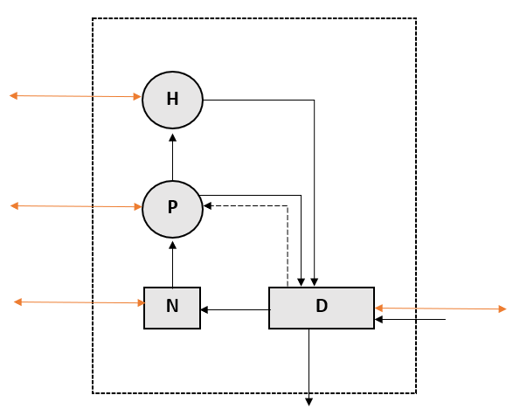

**Figure 1**. Flows of the nutrient in one patch of the two-patch meta-ecosystem model between detritus (D), nutrient (N), primary producers (P) and herbivores (H). Full black arrows represent flows between two compartments of the same patch; full orange arrows represent flows (migration/diffusion) between the same compartment in different patches; dashed arrows represent feedback from a compartment to another.

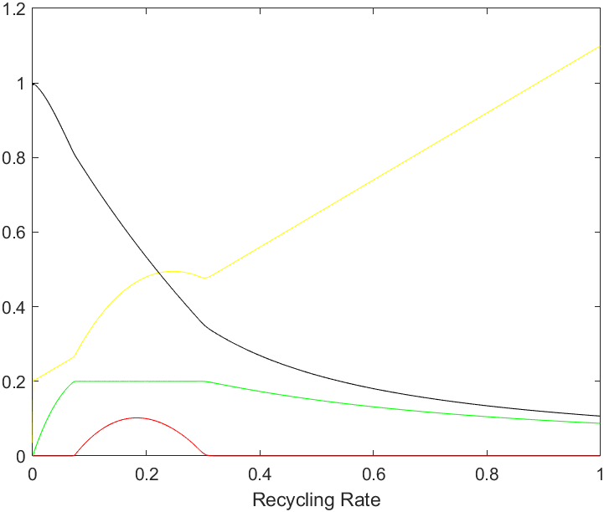

**Figure 2**. Change in the end values of detritus (black), nutrient (yellow), primary producers (green) and herbivores (red) when the recycling rate is changed from 0 to 1 (with 0.001 increments). Using the model described in this paper and the following parameters

*Ix*= *Iy*=*eD*=0.1,*mP*=*mH=*0.2, α=β=1, *dN*=0.1,

*dD*= *dH*= *dP*=0.

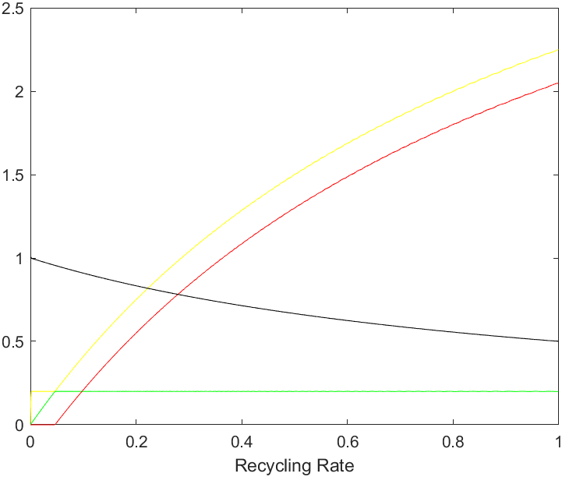

**Figure 3**. Change in the end values of detritus (black), nutrient (yellow), primary producers (green) and herbivores (red) when the recycling rate is changed from 0 to 1 (with 0.001 increments). Using a slightly change system of equations and the following parameters

*Ix*= *Iy*=*eD*=0.1,*mP*=*mH=*0.2, α=β=1, *dN*=0.1,

*dD*= *dH*= *dP*=0.

**Table with legend**

**Table 1.** Symbols used in the model and their definition

|  |  |
| --- | --- |
| Symbol | Definition |
| Parameters  *Ix*  *eD*  *mP, mH*  *r*  α  β  *dD*, *dN*, *dP*, *dH*  Variables  *D*  *N*  *P*  *H* | Detritus input rate  Detritus output rate  Mortality rate for the primary producers and herbivores, respectively  Recycling rate  Primary producer consumption rate of the nutrient  Herbivore consumption rate of the primary producer  Diffusion rate of the different compartments  Detritus  Inorganic nutrient  Primary producer  Herbivore |

**MATLAB code**

**Script 1**. System of equations of the model in a function named MyModelFx

function xdot=MyModelFx(~,x,p)

xdot=zeros(8,1);

%dN_x/dt

xdot(1,1)=-p.alphax*x(1)*x(3)+p.r*(1-p.eD)*x(7)+p.dN*(x(1)-x(2));

%dN_y/dt

xdot(2,1)=-p.alphay*x(2)*x(4)+p.r*(1-p.eD)*x(8)+p.dN*(x(2)-x(1));

%dP_x/dt

xdot(3,1)=p.alphax*x(1)*x(3)*(1-(x(3)/x(7)))-p.mP*x(3)-p.betax*x(3)*x(5)+p.dP*(x(3)-x(4));

%dP_y/dt

xdot(4,1)=p.alphay*x(2)*x(4)*(1-(x(4)/x(8)))-p.mP*x(4)-p.betay*x(4)*x(6)+p.dP*(x(4)-x(3));

%dH_x/dt

xdot(5,1)=p.betax*x(3)*x(5)-p.mH*x(5)+p.dH*(x(5)-x(6));

%dH_y/dt

xdot(6,1)=p.betay*x(4)*x(6)-p.mH*x(6)+p.dH*(x(6)-x(5));

%dD_x/dt

xdot(7,1)=p.Ix-p.eD*x(7)+p.mP*x(3)+p.mH*x(5)-p.r*x(7)+p.dD*(x(7)-x(8));

%dD_y/dt

xdot(8,1)=p.Iy-p.eD*x(8)+p.mP*x(4)+p.mH*x(6)-p.r*x(8)+p.dD*(x(8)-x(7));

**Script 2**. Template of code used to run simulations. This code was used to plot the amount of nutrient at the end of a simulation in each compartment for values of *r* from 0 to 1 (with increments of 0.001).

p.Ix=0.1;p.Iy=0.1;

p.eN=0.1;p.eD=0.1;

p.mP=0.2;p.mH=0.2;

p.alphax=1;p.alphay=1;p.betax=1;p.betay=1;

p.r=0;

p.dN=0.1;p.dD=0;p.dH=0;p.dP=0;

tspan=[0 1000];

%init=[N_x N_y P_x P_y H_x H_y D_x D_y]

init=[1 1 0.1 0.1 0.01 0.01 0.1 0.1];

matrix=zeros(1000,5);

opts = odeset('NonNegative',1:8)

for i=1:1000

matrix(i,1)=p.r;

[t,x]=ode45(@(t,x) MyModelFx(t,x,p),tspan,init,opts);

matrix(i,2)=x(end,1);

matrix(i,3)=x(end,3);

matrix(i,4)=x(end,5);

matrix(i,5)=x(end,7);

p.r=p.r+0.001;

end

figure(1)

plot(matrix(:,1),matrix(:,2),'y',matrix(:,1),matrix(:,3),'g',matrix(:,1),matrix(:,4),'r',matrix(:,1),matrix(:,5),'k')

xlabel("Recycling Rate")

**Script 3**. Function called EquilibriumPts that can be run alone or called in another script to give the numerical values of the equilibrium points of the system under fixed parameters.

function xstar=EquilibriumPts(p)

p.Ix=0.1;p.Iy=0.1;

p.eN=0.1;p.eD=0.1;

p.mP=0.2;p.mH=0.2;

p.alphax=1;p.alphay=1;p.betax=1;p.betay=1;

p.r=0.2;

p.dN=0.1;p.dD=0;p.dH=0;p.dP=0;

xstar=zeros(10,1);

%H*x

xstar(3,1)=((((p.Ix*p.r*(1-p.eD))/(p.mP*(p.eD+p.r)))+((p.mP*p.r*(1-p.eD))/(p.betax*(p.eD+p.r)))-((p.r*(1-p.eD))/(p.betax))-((p.mP)/(p.betax)))/(1-((p.mH*p.r*(1-p.eD))/(p.mP*(p.eD+p.r)))));

Hx=xstar(3,1)

%P*1x

xstar(2,1)=p.mH/p.betax;

Px=xstar(2,1)

%D*x

xstar(4,1)=(p.Ix+(p.mP*Px)+(p.mH*0.1))/(p.r+p.eD);

Dx=xstar(4,1)

%N*x

xstar(1,1)=(Dx/Px)*(p.r*(1-p.eD)/p.alphax);

Nx=xstar(1,1)